|  |  |  |
| --- | --- | --- |
| UnitecHorizontalLogo | **Test**  **Semester 1 2023**  **ISCG 7444 Cloud Application Design and Development** | |
| Computing, Electrical and Applied Technology | **Date:**  **Total Marks:**  **Course Weighting:**  **Time Allowed:** | Friday 26 May 2023  100  40%  120 minutes + 10 min extra |
|  | | |
|  | | |
| **Name**: Jiqiang WANG **ID**:1564710 Learning outcomes assessedDevelop specialist knowledge and critical understanding of Cloud computing concepts and technologies in order to solve real-world problems.Analyse software engineering methods used for designing, developing, and implementing Cloud-based software solutions.Investigate cloud-based software development techniques, including types of cloud infrastructure, providers, and cloud-based services in response to requirements specification.Instructions  * The test is open book. * Save this document: {ISCG7444 Test -2023 S1} on your computer. * Type your name, student ID on the top of this page and answer after each question. * Upload this document with your answers to the “ISCG7444 Test answers upload” link. * 10 minutes will be given towards the end of the test time to upload the document to the Moodle submission link. After that, the link will be disabled.  Summary of the test  |  |  |  | | --- | --- | --- | | **Section** | **Questions** | **Marks** | | A | 2 | 20 | | B | 1 | 80 | |  | **TOTAL** | **100** |   **Section A 20 MARKS**  **Instructions**   * Answer all questions. * Each question weighs 10 marks. | | | |

**Question 1**

1. What is cloud computing, and how does it differ (list at least two different points) from traditional computing models?(5 marks)

Cloud computing is a model for delivering computing resources over the internet, providing on-demand access to storage, processing power, and software applications. It differs from traditional computing models in two keyways:

1. Resource provisioning: Cloud computing allows users to scale resources up or down as needed, paying only for what they use, eliminating the need for upfront investments in hardware. Traditional computing models require organizations to purchase and maintain their own physical infrastructure, which can be costly and inflexible.
2. Accessibility and location independence: Cloud computing enables users to access resources and data from anywhere with an internet connection, promoting remote work and collaboration. Traditional computing models often require physical access to infrastructure, limiting flexibility and hindering remote accessibility.
3. What are the benefits (at least 2 points) and challenges (at least 2 points) of adopting cloud computing for organizations? (5 marks)

Benefits of adopting cloud computing for organizations:

1. Scalability and Flexibility: Easily scale resources based on demand, avoiding overprovisioning or underutilization.
2. Cost Efficiency: Eliminate upfront investments, pay only for resources used, reducing capital and maintenance costs.

Challenges of adopting cloud computing for organizations:

1. Security and Data Protection: Address concerns about data security, privacy, and compliance.
2. Dependence on Internet Connectivity: Reliance on stable internet connection for accessing cloud resources, potential disruptions in remote locations.

**Question 2**

What are the basic three service models in cloud computing, and what are the key differences among them? [10 marks]

The three basic service models in cloud computing are Infrastructure as a Service (IaaS), Platform as a Service (PaaS), and Software as a Service (SaaS).

1. Infrastructure as a Service (IaaS): Provides virtualized computing resources such as virtual machines, storage, and networks. Users have control over the operating system and applications while the cloud provider manages the infrastructure.
2. Platform as a Service (PaaS): Offers a platform and environment for developers to build, deploy, and manage applications. It provides a complete development and runtime environment, including programming languages, databases, and web servers, while abstracting away infrastructure management.
3. Software as a Service (SaaS): Delivers software applications over the internet on a subscription basis. Users can access and use the applications without the need for local installation or infrastructure management. The cloud provider handles maintenance, updates, and security.

Key differences:

* IaaS provides the most control and flexibility, allowing users to manage the entire infrastructure stack. PaaS abstracts away infrastructure management, providing a platform for application development. SaaS offers fully developed software applications with minimal user control over the underlying infrastructure.
* IaaS requires users to manage operating systems and applications, while PaaS provides a pre-configured environment for application development. SaaS offers ready-to-use applications without the need for user installation or configuration.
* IaaS allows users to scale resources up or down as needed, while PaaS and SaaS typically have predefined resource limits based on subscription plans.

**Section B 80 MARKS**

**Instructions**

* Answer all sub-questions.

**Question 3 Propose an application to address Auckland flooding problems (80 marks)**

Heavy rain and wind warnings were issued for across the North Island of New Zealand as Gabrielle approached the country, including red heavy rain warnings in Northland, Auckland, Coromandel, Gisborne District, and Hawke's Bay, and red wind warnings in Northland, Auckland, Coromandel Peninsula, and Taranaki. During 9 February 2023, states of emergency in place in Auckland and the Coromandel Peninsula as a result of earlier floods were extended in anticipation of Gabrielle's arrival, while a precautionary state of emergency was declared in Northland on 12 February. Many residents across the upper North Island who had been affected by earlier flooding prepared themselves for the cyclone, while emergency services were on high alert. Residents were warned that power cuts were likely and it was suggested that people withdraw some cash because electronic payment systems would not work in a power cut. People were encouraged to have three days of supplies.

Air New Zealand cancelled many domestic and international flights as the cyclone approached, while Bluebridge and Interislander cancelled Cook Strait ferry crossings. The Ministry of Education advised Auckland schools to close, but the decision remained with individual boards of trustees. Prime Minister Chris Hipkins said citizens should take the severe weather warning seriously and make sure they were prepared. Some authorities compared the likely effect of Gabrielle with the effects of Cyclone Hola (2018) and the devastating Cyclone Bola (1988).The cyclone brought gale-force winds to the North Island. During 12 February, areas of the upper North Island began experiencing widespread power outages and property damage as the outer edges of the cyclone swept the country, with over 225,000 homes losing power as conditions worsened through 13 and 14 February. Severe flooding occurred, while some buildings had their roofs torn off in the wind or were damaged by landslides. Numerous roads across the North Island were closed due to flooding and high winds, including Auckland Harbour Bridge. Hundreds of people across the North Island were mandatorily evacuated, while hundreds more self-evacuated. An estimated 10,000 people were displaced as a result of the cyclone. 1720 claims of injuries were accepted by ACC. On 23 February, there were 6960 reports of people uncontactable. Hundreds of police staff worked on locating those people and every person uncontactable was finally accounted for on 7 March.

The West Auckland communities of Piha, Karekare, Waimauku and Muriwai were heavily affected. Two firefighters died after being caught in a landslide in Muriwai. Two people went missing at sea near Great Barrier Island and Northland, but were both later found. 50 apartments were evacuated in Mount Eden on the evening of the 13th after engineers determined strong winds could cause the historic Colonial Ammunition Company Shot Tower to collapse. The tower was demolished a week later.224 buildings were red stickered across the region, meaning entry is prohibited, 323 were yellow stickered, meaning access is restricted, while 977 were white stickered, meaning minor damage only. Of these, 130 red stickered homes were in the town of Muriwai; nearly a third of all the homes in the town. Of the 600,000 customers connected to the Vector network, 42,000 were without power on 14 February. Most connection problems were fixed by 3 March.

Now your team is coming to Auckland Council help our Aucklanders create a pitch to convince Auckland Council to use digital technologies to address any of above problems.

(3.1) Identify a critical problem* to be addressed during the Auckland flooding and explain why do you think it is a good idea to design a Cloud Application system to address this problem (10 marks)

Problem: Information Sharing and Communication during Auckland Flooding.

During Auckland flooding, a critical problem is the lack of effective information sharing and communication just among residents. This hinders prompt response and can lead to delays in disseminating vital updates, warnings, and instructions.

Designing a Cloud Application system to address the problem of information sharing and communication during Auckland flooding is crucial. Here's why:

1. Real-Time Updates: The system provides instant updates on flood conditions, evacuation notices, and road closures, ensuring residents have the latest information.
2. Wide Accessibility: Residents can access the application easily through web browsers or mobile devices, enabling information dissemination to a large audience.
3. Centralized Communication: The system serves as a centralized platform for efficient collaboration and coordination among residents, emergency services, and authorities.
4. Scalability and Resilience: Cloud computing ensures the system can handle high data volumes and remain operational during peak usage, enhancing reliability.
5. Data Integration and Analysis: The system integrates data from various sources, enabling comprehensive analysis and proactive measures to mitigate flooding.

In conclusion, a Cloud Application system improves response efficiency, promotes public safety, and mitigates the impact of flooding by providing real-time updates, wide accessibility, centralized communication, scalability, and data analysis capabilities.

(3.2) Start small. Propose a set of features (at least 3) that could be developed in a Cloud Application to address the above problem you have identified. (10 marks)

Here are three key features that could be developed in a Cloud Application to address the problem of information sharing and communication during Auckland flooding:

1. Real-Time Alerts: The Cloud Application can provide real-time alerts to residents regarding flood warnings, evacuation notices, and other important updates. This feature ensures that residents receive timely information to take necessary actions and stay safe.
2. Communication Channels: The Cloud Application can offer communication channels such as chat rooms or forums for residents to connect, share information, and support each other during flooding events. This fosters community engagement and facilitates effective communication among residents.
3. Information Repository: The Cloud Application can serve as a central repository for important documents, guidelines, and emergency contacts related to Auckland flooding. This feature enables easy access to essential information for residents and helps them make informed decisions.

By incorporating these features, the Cloud Application can greatly enhance information sharing, communication, and community resilience during Auckland flooding events.

(3.3) Describe the system runtime and the basic functions and tasks that it would perform (10 marks)

The system runtime of the Cloud Application designed to address the problem of information sharing among residents during Auckland flooding would operate continuously, ensuring availability and accessibility whenever needed.

The basic functions and tasks that the system would perform include:

1. User Registration and Authentication: The Cloud Application would allow residents to register and create user accounts. It would authenticate users to ensure secure access to the system and protect sensitive information.

2. Information Sharing Platform: The system would provide a platform where residents can share relevant information, updates, and experiences related to flooding. They can post messages, upload photos or videos, and share valuable insights that can assist others during the event.

3. Emergency Alerts and Notifications: The Cloud Application would enable the dissemination of emergency alerts and notifications to residents. It would receive real-time updates from official sources such as emergency services and local authorities and push them to registered users to keep them informed about the current situation.

4. Interactive Maps and Visualizations: The system would incorporate interactive maps and visualizations that display flood-prone areas, affected infrastructure, evacuation routes, and other important information. This feature would help residents visualize the extent of the flooding and make informed decisions based on the provided data.

5. Communication Channels: The Cloud Application would facilitate communication between residents through features like chat rooms, forums, or direct messaging. It would allow residents to ask questions, seek assistance, or share information directly with each other to foster collaboration and community support.

­­

Overall, the system runtime of the Cloud Application would involve continuous user engagement, real-time information sharing, and collaboration among residents, ensuring efficient communication and support during Auckland flooding events.

(3.4) Describe what types of data are crucial for understanding and solving above problem and how can the cloud-based application collect and aggregate these relevant data, and what possible data analysis tasks to be conducted.

(10 marks)

The types of data crucial for understanding and solving the problem of information sharing during Auckland flooding include:

1. Flood-related Data: This includes real-time water levels, rainfall measurements, flood forecasts, flood-prone areas, and historical flood data. These data sources help in assessing the severity of the flooding, identifying high-risk areas, and predicting potential impacts.
2. Communication Data: This involves data related to emergency alerts, notifications, messages exchanged between residents, emergency services, and authorities, and community discussions. This data provides insights into the effectiveness of communication channels, response coordination, and information needs.
3. Infrastructure Data: This comprises data on road closures, power outages, damaged buildings, and other infrastructure-related issues. By collecting this data, the application can provide up-to-date information on affected areas, infrastructure conditions, and restoration efforts.

The cloud-based application can collect and aggregate these relevant data by integrating various sources, such as weather monitoring stations, flood sensors, communication logs, social media feeds, and official reports. Data can be transmitted in real-time to the cloud, where it is stored, processed, and analyzed.

(3.5) Describe two services that will enable your system as a Cloud Application (10 marks)

Two services that will enable the system as a Cloud Application are:

1. Cloud Storage Service: The Cloud Application will utilize a cloud storage service to securely store and manage the collected data. This service provides scalable and reliable storage capabilities, allowing the application to store large volumes of flood-related data, communication logs, infrastructure information, and other relevant data sources. Cloud storage ensures data durability, accessibility, and efficient retrieval for analysis and real-time processing.

2. Communication and Messaging Service: The Cloud Application will leverage a communication and messaging service to facilitate seamless and real-time communication among residents, emergency services, and authorities. This service enables the application to send notifications, alerts, and updates to targeted recipients based on their geographical location or subscribed preferences. It also provides a platform for residents to report incidents, request assistance, and receive important instructions during flooding events. The communication and messaging service ensures reliable and efficient information sharing, enhancing coordination and response efforts.

(3.6) Critically evaluate Public and Private cloud deployment models for the system and recommend one (8 marks for the evaluation and 2 marks for the recommendation) (10 marks)

Public and Private cloud deployment models have distinct characteristics that should be evaluated to determine the most suitable option for the Cloud Application system addressing information sharing and communication during Auckland flooding:

1. Public Cloud:

- Evaluation: Public cloud deployment offers scalability, cost-effectiveness, and ease of management. It provides access to a shared pool of computing resources hosted by a third-party provider. The system can leverage the provider's infrastructure, reducing the need for upfront investment and ongoing maintenance. However, data security and privacy concerns may arise due to the shared nature of the infrastructure, potentially impacting sensitive information.

2. Private Cloud:

- Evaluation: Private cloud deployment provides greater control and security as the infrastructure is dedicated solely to the organization. It offers customization options, enhanced data privacy, and compliance adherence. However, setting up a private cloud requires significant upfront investment and ongoing maintenance costs. It may also limit scalability compared to public cloud options.

Recommendation:

Considering the criticality of information sharing and communication during Auckland flooding, and the need for secure and reliable data handling, a Private Cloud deployment model is recommended for the Cloud Application system. The sensitive nature of the data involved in flood-related communications and the requirement for stringent privacy measures align well with the dedicated infrastructure and increased control offered by a private cloud.

(3.7) Design a Windows Navigation Diagram (WND) with at least 4 screens (one for each process described in above and a main window)

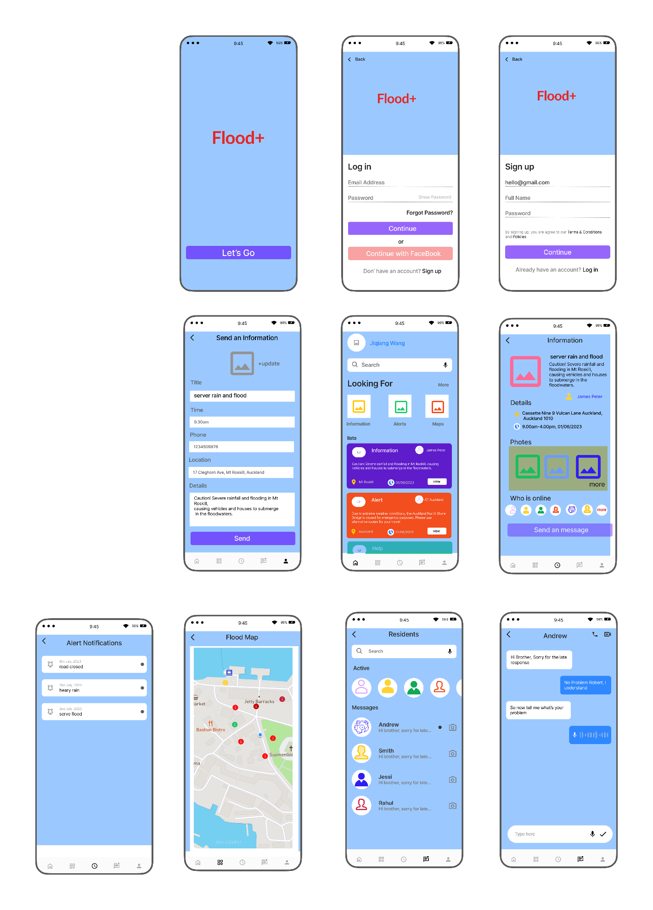 (10 marks)

(3.8) Describe the possible concerns such as security, privacy or scalability for the above application

(10 marks)

The Cloud Application system for information sharing and communication during Auckland flooding may encounter various concerns related to security, privacy, and scalability. These concerns include:

1. Security:

- Data Breaches: There is a risk of unauthorized access or data breaches, potentially compromising sensitive information related to flood alerts, evacuation plans, and personal details of residents.

- Network Security: The system needs robust network security measures to protect against cyber threats, such as hacking attempts, malware, and Distributed Denial of Service (DDoS) attacks.

- Authentication and Access Control: Ensuring secure user authentication and implementing access control mechanisms is crucial to prevent unauthorized access and data manipulation within the system.

2. Privacy:

- Data Privacy: The Cloud Application should adhere to privacy regulations and protect the personal information of individuals involved in flood-related communication. Proper data anonymization and encryption techniques should be implemented.

- Consent and Authorization: Obtaining consent from users to collect and process their data is essential. The system must also enforce appropriate authorization levels to restrict access to sensitive information.

3. Scalability:

- Handling Increased Workload: During a flood event, the system may experience a sudden surge in traffic and data volume. Ensuring the infrastructure and resources can scale up seamlessly to handle increased workload is crucial for maintaining system performance and responsiveness.

- Resource Allocation: The Cloud Application should efficiently allocate resources to handle concurrent user requests and data processing without experiencing bottlenecks or slowdowns.

Addressing these concerns requires implementing robust security measures, adhering to privacy regulations, and designing a scalable infrastructure that can handle peak loads. Regular security audits, encryption of sensitive data, and continuous monitoring of system performance are essential for mitigating risks and ensuring a secure and reliable Cloud Application for information sharing and communication during Auckland flooding.

**\*Note on possible problems**

**Information and Resource Sharing:**

a. How can a cloud-based application facilitate the sharing of critical information among residents, emergency services, and city officials during flooding events?

b. What features can be implemented to enable residents to report their status, request assistance, and share information about their immediate needs?

c. Can the application provide a centralized platform for emergency services and volunteers to coordinate their efforts and efficiently allocate resources?

**Communication and Contact:**

a. How can the cloud-based application address the issue of lost contact during flooding events when traditional communication channels may be disrupted?

b. Can the application leverage alternative communication methods, such as satellite connections or mesh networks, to ensure continuous communication among residents and emergency responders?

c. What mechanisms can be implemented to provide real-time updates and instructions to residents regarding evacuation routes, safe zones, and emergency contact information?

**Power Supply and Backup:**

a. How can the application address the challenges posed by power cuts during flooding incidents?

b. Can the application rely on alternative power sources, such as renewable energy or mobile generators, to ensure uninterrupted service availability?

c. What strategies can be implemented to conserve power and optimize the application's functionality during power-constrained situations?

**Safety and Emergency Services:**

a. How can the cloud-based application contribute to improving safety measures for residents during flooding events?

b. Can the application provide real-time alerts and warnings regarding potential hazards, road closures, and evacuation orders?

c. What features can be incorporated to assist emergency services in identifying and prioritizing areas that require immediate assistance?

**Health and Medical Support:**

a. How can the cloud-based application address the health-related challenges faced during flooding incidents, such as access to medical assistance and medication?

b. Can the application provide information on nearby medical facilities, availability of medical supplies, and emergency medical services?

c. What mechanisms can be implemented to support the delivery of telemedicine or remote healthcare services to affected residents?

**Accessibility and Inclusivity:**

a. How can the application ensure accessibility and inclusivity for all residents, including those with disabilities or language barriers?

b. Can the application provide multilingual support and assistive technologies to cater to diverse user needs?

c. What strategies can be implemented to address the specific challenges faced by vulnerable populations, such as the elderly or individuals with limited mobility?